Report for: | Cabinet
Date of Meeting: | 15 February 2024
Subject: | Electric Vehicle (EV) - Rapid and Ultra Rapid Charging in Harrow
Key Decision: | Yes
Responsible Officer: | Dipti Patel, Corporate Director for Place.
Portfolio Holder: | Councillor Anjana Patel, Portfolio Holder for Highways, Infrastructure and Community Safety
Exempt: | Public with the exception of exempt appendices 1, 2 and 3, by virtue of paragraph 3 of Schedule 12A of the Local Government Act 1972, being information relating to the financial or business affairs of any particular person (including the authority holding that information)
Decision subject to Call-in: | Yes
Wards affected: | Multiple wards
Enclosures: | Appendix 1 (exempt): Draft Invitation to Tender  Appendix 2: (exempt) Draft Heads of Terms  Appendix 3: (exempt) Draft Technical Specifications and KPI’s  Appendix 4: Evaluation Methodology and KPI’s

Section 1 – Summary and Recommendations
This report sets out the proposal to procure rapid and ultra rapid charge points at a number of council-controlled locations (car parks and on-street) in the borough.

Recommendations:
Cabinet is requested to:

- Note the feasibility work that has been undertaken to identify key sites in car parks and on-street that may be suitable for Electric Vehicle (EV) rapid and ultra rapid charge points to be installed and maintained by specialist third party operators, subject to the outcome of procurement.
- Approve the procurement for the selection of suitable Charge Point Operators (CPO) to supply, install and operate rapid and ultra rapid charge points via the Oxford Dynamic Purchasing System (DPS) or such other compliant procurement route as may be determined by the Corporate Director for Place in consultation with the Head of Procurement.
- Approve the draft tender documents.
- Delegate authority to the Corporate Director for Place, following consultation with the Portfolio Holder for Highways, Infrastructure and Community Safety, to:
(i) Make any necessary amendments to the procurement documents prior to publication.
(ii) Award contracts to one or more successful CPOs, to include entering into required leases or licences and all other necessary legal documentation.

Reason: (for recommendations)
The recommendations enable the Council to support the transition to electric vehicles and decarbonisation of travel in the borough in accordance with the aims of its adopted Electric Vehicle Strategy.

Section 2 – Report

Introduction

The London Borough of Harrow’s Electric Vehicle Strategy was adopted in November 2023 and sets out the vision, objectives and an action plan to support the transition to Electric Vehicles (EVs) in Harrow over the next 15 years to 2038. This will be achieved by facilitating provision of a reliable, accessible, and equitable network of electric vehicle charging infrastructure throughout the borough whilst also addressing local barriers to EV adoption.

The EV Strategy in turn supports the borough’s draft Long Term Transport Strategy, which sets out the Council’s ambitions for a transport system that is more accessible, safer and greener over the next 20 years, and also contributes to the overarching decarbonisation objectives of the Council’s agreed Climate and Nature Strategy 2023-30.

This report recommends progression of an initial procurement of rapid and ultra rapid charge points in council-controlled locations in order to advance delivery of the Electric Vehicle Strategy.

Options considered.

The options are either.

- to give authority to proceed with the procurement of rapid and ultra rapid charge points and to award the contract to the winning bidder(s).
- not to approve the procurement and delegate authority to award this contract.

It is recommended to proceed with procurement and delegate authority to award as failure to do so will not advance the Council’s decarbonisation aims, not meet the Council’s objectives within the EV Strategy and will fail to support residents and businesses in the transition to electric vehicles.

Given the timescales and availability of a suitable Dynamic Purchasing System (DPS), where EV providers have already been financially and technically vetted, and can be procured relatively quickly, there is no need for the Council to undertake a lengthy full open tendering process for this procurement. The Oxford City Council DPS is an award-winning procurement framework and provides the Council with a compliant route to market.

Background

It is anticipated that by 2035 100% of new car and van sales will be electric to meet the government’s national net zero by 2050 target. The Climate Change Committee has recommended that if the UK is to meet the 2050 net zero target, 100% of new vehicle sales should be electrically propelled by 2035 at the latest (and ideally by 2030).

The focus of Harrow’s Electric Vehicle Strategy is therefore to expand EV charge point installations as demand from residents is high and the need for residential, fast, rapid, and ultra-rapid charge points for commuters and businesses will increase over coming years.

Current situation

Harrow overview

Until 2023, Harrow Council’s focus has largely been providing charge points in locations requested by residents and/or businesses. However, following the adoption of the EV Strategy, the Council aims to roll out more charge points through an ambitious approach by providing charge points based on underlying demand potential, alongside rapid and ultra rapid charging hubs on the strategic road network and within town centres.

There are currently about 3,500 electric vehicles in Harrow which is less than 3.4% of total registered vehicles. However, the Council anticipates this will increase to nearly 10% in 2026 (9,500 vehicles), over 60% in 2038 (68,000 vehicles) and approach 100% by 2050. EV penetration in Harrow currently trends with adjacent local authorities outside London. In addition, since the pandemic, EV penetration of new car sales has shown strong growth within the UK.

In addition to home-based charging solutions, Harrow currently has around 64 public charge points including 57 lamp column (3kW) and fast (7-22kW) and seven Rapid (>50kW) charge points at both publicly and privately owned land in Harrow.

The current mix of charging provision in Harrow, both public and private, along with the number of local electric vehicles registered in the borough, is summarised below. The types of electric vehicle shown are BEV Battery Electric Vehicle (BEV); Battery Electric Vehicle + Range Extender (REX), and Plug-in Hybrid Electric Vehicle (PHEV).

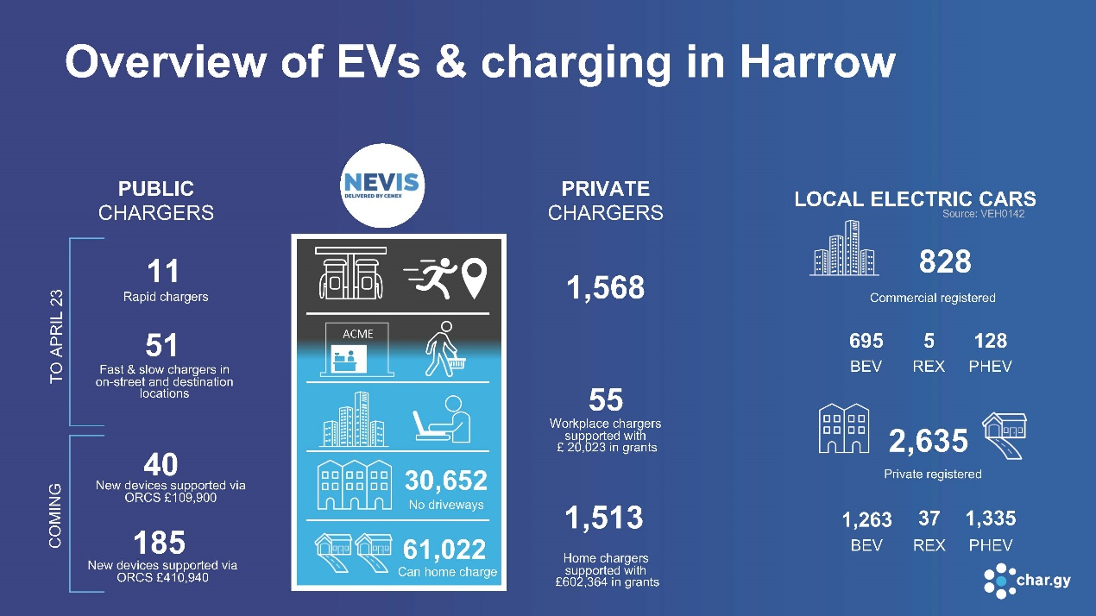

Projected Electric Vehicle Infrastructure (EVI) requirement for Cars and Large Goods Vehicle’s (LGV’s) in Harrow
Initial data from Cenex for the borough indicates that a substantial and sustained programme of expansion of EV charging provision will be required to meet future demand through to 2030. This data, and the mix and locations of demand, is further explored and modelled through the Council’s EV Strategy.

Data summary

Based on our projections, a total of 356 EV charge points will be required on council land by 2026, which will increase to 851 by 2033 and 1,240 by 2038.

 | By 2026 | By 2033 | By 2038
Standard (<22kW) | 330 | 775 | 1,116
Rapid (50kW) | 25 | 67 | 108
Ultra-rapid (>150kW) | 1 | 9 | 16

Council Progress

Since the start of Harrow’s electric vehicle charge point programme in 2018, 30 charge points have been installed in residential and commercial areas. Five charge points were installed as part of the Neighbourhoods of the Future Greenhill Go Ultra Low City Scheme. 24 residential charge points were installed using On-Street Residential Charge Point (ORCS) funding. 1 rapid charge point was commissioned in March 2023.

The table below details the type of charge points that have been installed by Harrow:

No of Chargepoints | Charge Point Operator | Year of Installation | Charging type | Power Output
2 | BP Pulse | 2018 | Slow | 7kW
3 | BP Pulse | 2018 | Fast | 22kW
24 | Char.gy | 2021 | Slow | 5.1kW
1 | BP Pulse | 2023 | Rapid | 50kW

Slow chargers are up to 7Kw units mounted on or in streetlighting columns providing for a slow overnight charge. Fast chargers, typically around 22kw, are bollard sized units located on dedicated parking spaces, providing a charge to 80% in 3-4 hours. Rapid chargers 50Kw and over, are a petrol pump sized unit providing charge to 80% in under an hour for most electric vehicles.

The Council has taken the opportunity to apply to various funds to provide support with EV installations. In 2018 the Go Ultra Low City Scheme (GULCS) provided funding for the first 5 on-street chargers as part of the Greenhill Go Ultra Low City Scheme. In 2019 the On-Street Residential Chargepoint Scheme (ORCS) provided funding for 24 Lamp Column charge and GULCS 1 rapid charge point. An additional 225 residential lamp column chargers will be delivered in 2024 at various locations in Harrow. Delivery of the charge points is supported by ORCS.

Frameworks save significant time and money, while delivering specific services that not only meet local requirements but support local decision making. The recommendation for this report is to secure a provider through a call for competition under the Oxford City Council DPS.

Rapid and Ultra Rapid Charging Provision in Council Car Parks and other locations

The installation of residential on street charging provision, which is suitable for longer stay and overnight charging, should also be supplemented by faster charging options. The Council has carried out market engagement with rapid charging providers with a view to better understanding the market and identifying suitable locations across our car park estate, and other on and off-street locations close to town centres and high footfall sites. The key findings from these initial discussions are:

- To justify the higher capital levels of investment required in the equipment for rapid and ultra rapid charging providers generally require licence or lease terms of 10-20 years. Sites therefore require careful selection to ensure they are not likely to be subject to development within those timescales, and otherwise offer the shorter visitor dwell times appropriate for rapid and ultra rapid charging.

- Electricity capacity upgrades are almost always required for installation of all types of rapid chargers, which can range in output from 50kw to 300kw, and sites need to be selected where this is economically viable to achieve. The timescales for installation of rapid and ultra rapid charging provision are generally around 12 months allowing for capacity upgrade works, although this can be shorter for smaller installations.

- Subject to securing the length of tenure required, costs of installation and capacity upgrades are borne by the provider, with an annual rental and / or profit share arrangement paid to the landowner.

- The potential for expansion of rapid charging in the borough is good and providers are keen to work within Harrow.

The council-controlled locations where rapid and ultra rapid charging infrastructure can potentially be installed, and which will be included in the tender recommended by this report are set out in the table and map below. The indicative location and numbers of EV bays within the specific sites are further shown on the plans at Appendix 3. The final locations and numbers of bays instructed via the contract will be subject to the detailed responses from market and discussions with operators once the contract has been awarded. This will take into account viability assessments as to the location of electrical infrastructure as well as accessibility considerations for users. It is highly likely that all sites will require electrical upgrades, to include new substations and cabling where multiple faster chargers are to be installed.

The proposed sites and wards are as follows:

Site Name | Ward
Belmont car park | Belmont
Cambridge Road car park | North Harrow
Chapel Lane car park | Pinner South
Greenhill Way car park | Greenhill
Leisure Centre car park | Wealdstone
Headstone Manor car park | Headstone
Harrow Arts Centre car park | Hatch End
Grimsdyke car park | Hatch End
Stanmore Broadway and car park | Stanmore
Whitby Road and Northolt Road | Roxeth
Love Lane car park | Pinner

.

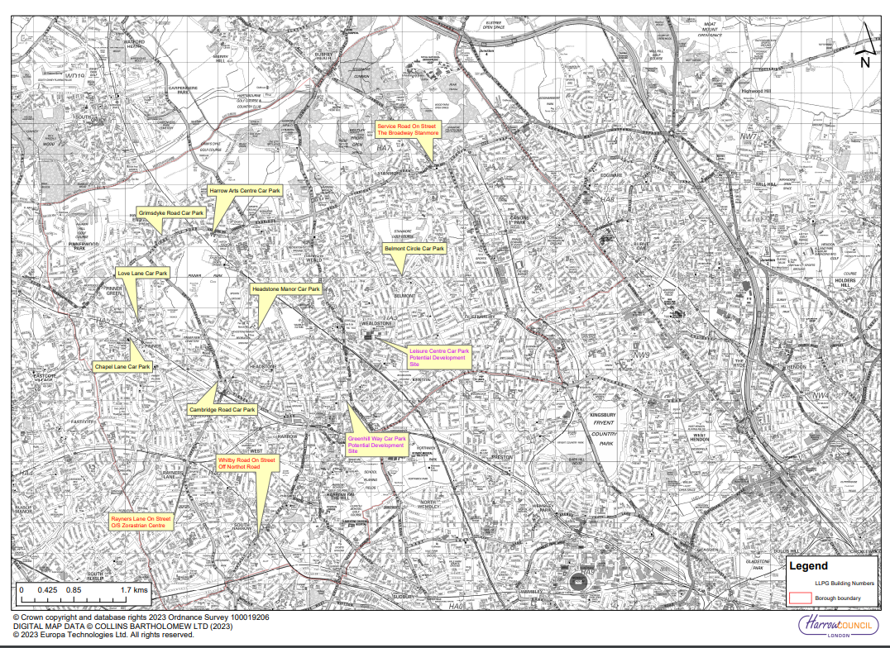

It is conceivable that some sites may be subject to development proposals within the timescales that operators are likely to require for licence arrangements, in order to recoup their upfront capital costs. It is proposed therefore that the contractual documentation details compensation arrangements that would be payable by the Council for early termination, so that a fully informed decision can be made whether to proceed with more sensitive sites.

Why a change is needed.

Many residents have made the decision to switch to EV or use an EV for work purposes.

Fast and rapid charge points offer a solution to commuters travelling longer distances and those who need to charge quickly. As highlighted by the Electric Vehicle Strategy, Harrow needs to expand its provision of rapid charge points. The current rapid charge points in Harrow operate in the following way:

Tarrif (£/kWh) | Subscribers | Pay as you go | Contactless/Guest
AC 7kW | £0.44 | £0.59 | £0.59
Rapid (AC 43kW / DC 50kW​) | £0.63 | £0.77 | £0.79
Ultra-rapid (DC 150kW+​) | £0.69 | £0.83 | £0.85

As the charge point market continues to expand, the availability of funding is gradually being reduced, with the expectation that installation and operational costs are met by Councils and the market, especially for rapid charging solutions. Harrow will continue to make the most of funding schemes for residential charging, however the council should be prepared to look for alternative ways to ensure the continuing viability in future years. In the context of the recommendations in this report, it is assumed that the rapid and ultra rapid charge points and associated electrical infrastructure will be 100% funded by the market.

Reasons for Recommendation

- The rollout of further rapid and ultra rapid charge points directly implements the EV Charging Strategy and plays a key role in the reduction of transport-based emissions and is integral to meeting net zero targets. Furthermore, it will support the council in meeting transport decarbonisation objectives set out in the Climate and Nature Strategy.

- Ad-hoc development of EV charging in Harrow to date means an accelerated and effective programme is required to work towards a net zero transport system. Harrow are in the process of supporting residents who already own electric vehicles through new lamp post charging solutions. While lamp columns are currently the preferred type of infrastructure for charging in residential areas, and residential charging provision will remain the mainstay of future charging infrastructure locally and nationally, faster charging provision in other areas such as Town Centres, Council Car Parks and main routes are also crucial in expanding options in Harrow and enabling the progressive electrification of road transport in the borough. This will help commuters and businesses needing to charge more quickly or for longer journeys. The availability of greater numbers of rapid and ultra rapid chargers locally will encourage the uptake of EV ownership in the borough.

Harrow will establish a concession through which one or more private sector charge point operators (CPO) will secure a licence to fund, install and operate EV charging infrastructure on identified sites throughout the Borough. The Concession will include as few as 11 and as many as 50 rapid and ultra rapid charge points rated at 50kW or faster. All EV charge infrastructure within the Concession is to be installed by year-end 2027. The Concession’s term, to be proposed by the CPO, will be concurrent with estimated useful life of the installed EV charge infrastructure and should not exceed the time that the CPO could reasonably be expected to take to recoup the investments made in operating the charging points with a return on invested capital taking into account the investments required to achieve the specific contractual objectives. The licensed CPO will operate a retail EV charging infrastructure operation from installed EV charging bearing responsibility for energy procurement, pricing and revenue collection, device maintenance, customer experience and all other operational activities associated with the Project. The licensed CPO will also bear all commercial, technical and regulatory risk for the Project. As remuneration for the licence, the licensed CPO will pay the Council a monthly fee (the Licence Fee) proposed by the CPO and accepted by the Council.

Implications of the Recommendation

Resources, costs
This report requests that Cabinet approves proposals to procure and delegates authority to award a contract for the installation and maintenance of rapid and ultra rapid charging infrastructure in Harrow.

The proposed procurement will secure a partner that can meet project deliverables and will enable the installation of between 11 and 50 charge points by 2027.

By undertaking the procurement exercise, Harrow would not obligate itself to enter a contract until a decision to award has been made by the Corporate Director for Place in consultation with the Portfolio Holder for Highways, Infrastructure and Community Safety, and in accordance with the Council’s Contract procedure rules.

The proposed commercial model is a concession contract that provides for CPOs to pay all up-front capital costs for installation of the charge points along with ongoing maintenance costs.

Ward Councillors’ comments
Relevant ward councillors will be informed of any sites to be taken forward within their wards as a result of this procurement and prior to the commencement of any works on site.

Environmental Implications

The installation of charge points will directly facilitate the decarbonisation of transport in the borough, and over time will also improve air quality and public health outcomes locally.

Risk Management Implications
Risks included on corporate or directorate risk register? No

Separate risk register in place? Yes

The relevant risks contained in the register are attached/summarised below. Yes

The following key risks should be taken into account when agreeing the recommendations in this report:

Risk Description | Mitigations | RAG Status
Project delays - Without Rapid and ultra rapid charging infrastructure there is a risk that the councils transport network will not be able to respond to changes in the environmental, economic, health and social context. In understanding this, it allows the Harrow transport network to evolve in response to this for the benefit of users. | - Agree to procure, award and roll out a rapid and ultra rapid charge point programme. | Amber
Community support/opposition Not rolling out rapid and ultra rapid charging infrastructure in Harrow gives residents, visitors and investors the impression that Harrow does not care about its transport network and might discourage them from wanting to live in, work in and visit Harrow. | - Agree to procure, award and roll out a rapid and ultra rapid charge point programme. | Green
Delays in procurement - If the proposed recommendation(s) are not agreed, the expansion of electric vehicle charging on Council owned assets in the borough will not proceed, or be delayed, and wider progress on the LBH Climate and Nature Strategy and EV Strategy slowed | - Agreement to the report’s proposed recommendation(s) will mitigate this risk | Green
No responses to procurement - Council unable to procure a suitable Charge Point Operator and concession agreement. | - Making use of the Oxford City Council DPS as pre-qualified providers have been appointed to the DPS and the DPS contains a concession call-off contract template. | Green

Procurement Implications
The procurement strategy to appoint a charge point operator is to use the Oxford City Council Dynamic Purchasing System (DPS). This DPS is an award-winning framework that provides the Council with a compliant route to run a competitive tender. The DPS is an open framework which enables any supplier to join, providing they pass financial and technical vetting. This ensures that the Council has access to a number of market-leading and capable chargepoint operators.

This route to market is compliant with the Procurement Contract Regulations 2015 and provides an opportunity for the Council to select a capable supplier. It will require all tenderers to provide technical and commercial submissions, with all tenders evaluated for both technical and commercial suitability in relation to the Council’s requirements. More information can be found in Appendix 1

The evaluation criteria will be split across Quality, Social Value and Commercial using the below proportions.

- Quality: 40%
- Social Value: 10%
- Commercial: 50%

As per s.18 Concession Contracts Regulations 2016, the length of this contract has been considered so as to ensure it does not exceed the time that the contractor could reasonably be expected to take to recoup the investment, taking into account a reasonable return on invested capital. The length of this contract is expected to be between 10 and 20 years. This has been deemed appropriate for the substantial capital investment that the contractor will need to provide. The contractor will incur substantial costs during the lifetime of the contract. This includes the provision of 50 rapid or ultra-rapid chargepoints, which will require a full upgrade and installation at least once during the lifetime of the contract. This infrastructure installation and upgrade is estimated to cost approximately £3.75 million. The estimated lifetime for a chargepoint is between seven and ten years. We have estimated the cost of a charge point cabinet (provides two chargers) over the length of the contract to be £70k each, totalling between £3.5m and £5.25m. The contractor is also required by contractual obligation to provide a number of Service Levels, which cover maintenance and energy management throughout the contractual period. Back Office support for customers will also be provided and covered by the charge point operator. This is required to be available 24 hours a day and available all year round and will incur further costs.

The contract length is line with contract lengths for comparable contracts awarded by other London boroughs and local authorities. The Council will be requiring a revenue share as part of the chargepoint contract for the use of the chargepoints. This is estimated to be between 10 and 20 percent of revenue and this substantial share will lengthen the time required for the contractor to recoup their investment and a reasonable return.

Legal Implications

The Traffic Management Act 2004 places obligations on highway authorities to ensure the expeditious movement of traffic on their road network. Authorities are required to make arrangements as they consider appropriate for planning and carrying out the action to be taken in performing the duty.

Under section 16 of the London Local Authorities and Transport for London Act 2013, the Council has the power to provide and operate, or grant permission to a person to provide and operate, charging apparatus for electric vehicles.

The Council must comply with its Constitution and Contract Procedure Rules (CPRs). A concession arrangement, greater or equal to the financial threshold (£5,372,609) must also comply with The Concession Contracts Regulations 2016 (CCR). The value of the concession is the total turnover of the concessionaire generated over the duration of the contract, inclusive of VAT, as estimated by the Council, in consideration for the works and services and for the supplies incidental to such works and services. If this exceeds the financial threshold of £5,372,609 the CCR will apply.

Legal is satisfied that the Council can lawfully access the Oxford City Council DPS as it is open to all UK public sector bodies including local authorities and the Council has signed the relevant Access Agreement enabling the Council to use the DPS, providing that the Council complies with the rules of the DPS. The DPS currently expires on 30th August 2025 (subject to extension or re-procurement).

As the estimated value of the procurement meets or exceeds £500,000, approval to procure must be obtained by way of a Cabinet Report and a Cabinet decision must be obtained prior to any tender activity commencing, as required under the Council’s CPRs (Table 1 Authorisation and Acceptance Thresholds).

Financial Implications
Soft market testing has indicated that the market will be able to fully fund the installation costs of new rapid and ultra rapid charge points in exchange for a licence of a defined term of years (typically 10-20) of particular sites. This enables the operator to have surety of operation for sufficient time to recoup its operational investment and make a return. In addition, a licence fee and / or profit share arrangements would yield a return to the council. The commercial terms offered will be tested at tender stage and form part of the tender evaluation.

In the current Medium Term Financial Strategy (MTFS), there is a target of
£300k to be achieved over 2 years (2024/25 and 2025/26) from EV charging
Points. The resulting savings from this procurement will be expected to meet this MTFS target.

Equalities implications / Public Sector Equality Duty

A draft Equalities Impact Assessment (EQIA) has been prepared for the long-term Transport Strategy, which considers the impact of transport and future changes (including the electrification of vehicles) upon those with protected
characteristics, and has therefore informed the development of the EV Strategy. The elderly, disabled and those who are pregnant are currently more reliant upon vehicular transport than the population at large, and this will remain the case over coming years. Whilst the provision of a comprehensive electric vehicle charging network will benefit Harrow residents with or without those protected characteristics, it will benefit these groups to a greater degree, for whom non-vehicular methods of transport are not easily accessible. Similarly, a failure to provide adequate electrical vehicle charging infrastructure within Harrow will (as fossil fuel vehicles become more expensive and less common over time) disproportionately affect them. The draft EQIA will be kept under review and updated as necessary in light of consultation feedback relating to the long-term transport strategy. In the context of the rapid and ultra rapid charge points to be procured, accessibility considerations for the mobility impaired will be considered at the design stage.

Council Priorities

The expansion of EV charging provision aims to deliver a lower carbon
borough. It will help deliver the Council’s overall vision of Restoring Pride in
Harrow by realising the opportunities of new jobs and investment in Electric
Vehicles and associated infrastructure, improved health and air quality and a
more pleasant, thriving environment for local people.

The increase in public charging helps to put residents first by delivering much needed infrastructure to enable greater levels of green mobility in Harrow and contributes to a borough that is clean and safe.

Section 3 - Statutory Officer Clearance
Statutory Officer: Comie Campbell
Signed on behalf of the Chief Financial Officer
Date: 26 January 2024

Statutory Officer: Mellissa Trichard
Signed on behalf of the Monitoring Officer
Date: 26 January 2024

Chief Officer: Dipti Patel
Signed off by the Corporate Director
Date: 26 January2024

Head of Procurement: Matthew Hazelton
Signed on *behalf of the Head of Procurement
Date: 18 January 2024

Internal Audit: Neale Burns
Signed on behalf of the Head of Internal Audit

Date: 19 January 2024

Has the Portfolio Holder(s) been consulted? Yes

Mandatory Checks

Ward Councillors notified: NO, as it impacts on all Wards

EqIA carried out: YES

EqIA cleared by: No (part of the Long Term Transport Strategy EQIA)

Section 4 - Contact Details and Background Papers
Contact: Mehmet Mazhar, Head of Traffic, Highways and Asset Management
Tel: 07549629678
Email: Mehmet.mazhar@harrow.gov.uk
Background Papers: None Call-in waived by the Chair of Overview and Scrutiny Committee: No

